**DAILY ONLINE ACTIVITIES SUMMARY**

|  |  |  |  |  |  |  |  |  |
| --- | --- | --- | --- | --- | --- | --- | --- | --- |
| **Date:** | **30-05-2020** | | | | | **Name:** | **Shiza Amreen.J** | |
| **Sem & Sec** | **4th sem B sec** | | | | | **USN:** | **4AL18CS078** | |
| **Online Test Summary** | | | | | | | | |
| **Subject** | | **1.Data Communication**  **2.Complex Analysis, Probability and Statistical Methods** | | | | | | |
| **Max. Marks** | | **1.30**  **2.30** | | **Score** | | | **1.25**  **2.27** | |
| **Certification Course Summary** | | | | | | | | |
| **Course** | **Python for Machine Learning** | | | | | | | |
| **Certificate Provider** | | | **GreatLearning** | | **Duration** | | | **5 Hours** |
| **Coding Challenges** | | | | | | | | |
| **Problem Statement: Write a C Program to count Uppercase, Lowercase, special character and numeric values for a given String** | | | | | | | | |
| **Status: yes** | | | | | | | | |
| **Uploaded the report in Github** | | | | | **yes** | | | |
| **If yes Repository name** | | | | | **Lockdown_Coding** | | | |
| **Uploaded the report in slack** | | | | | **yes** | | | |

Online Test Details:

Today I had Data and Communication IA-2, and got 25 out of 30.

Later I had **Complex Analysis, Probability and Statistical Methods IA-2, and got 27 out of 30.**

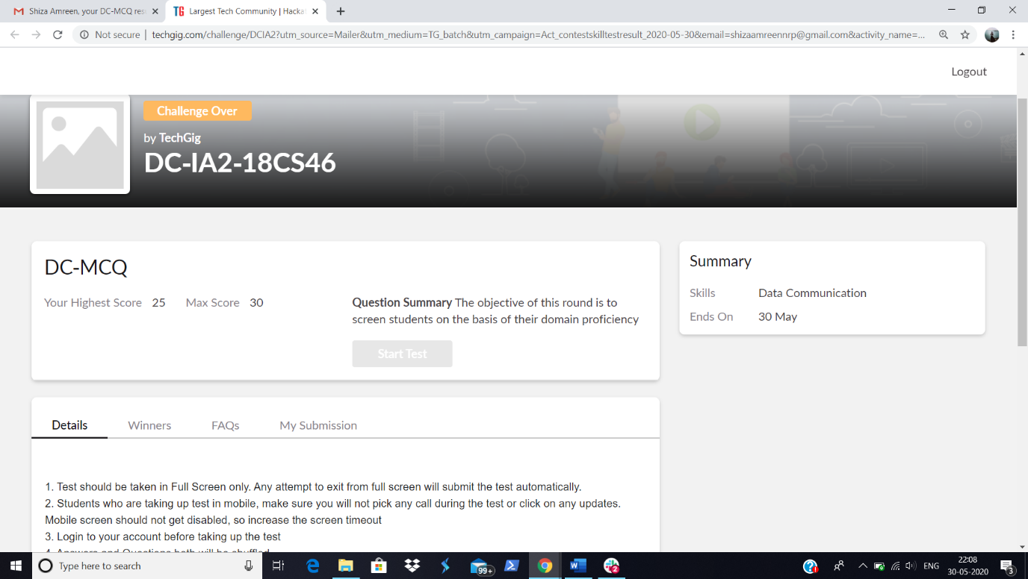

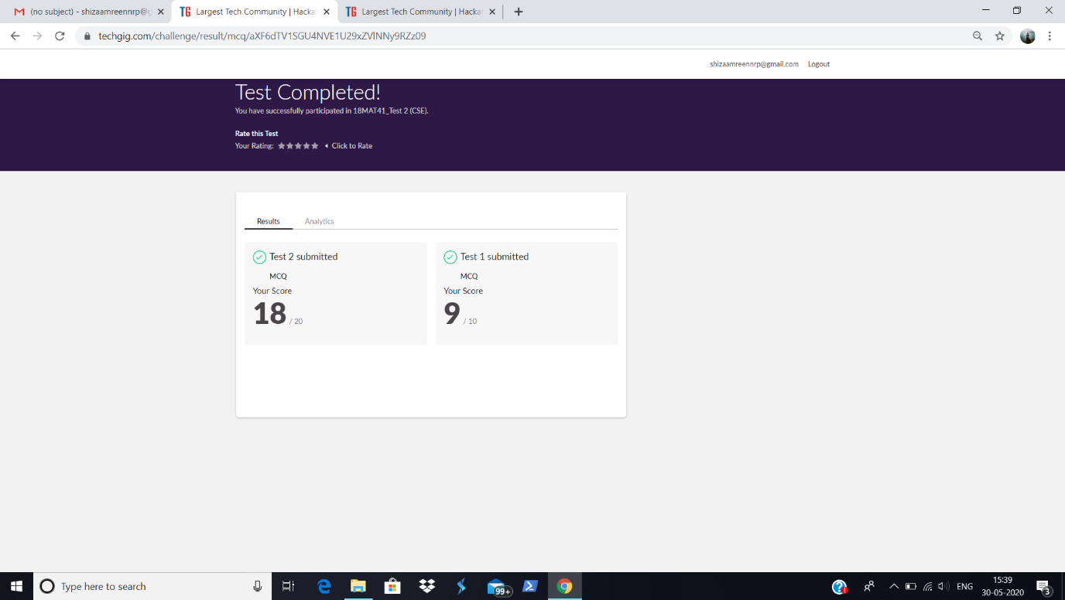

Certification Course Details:

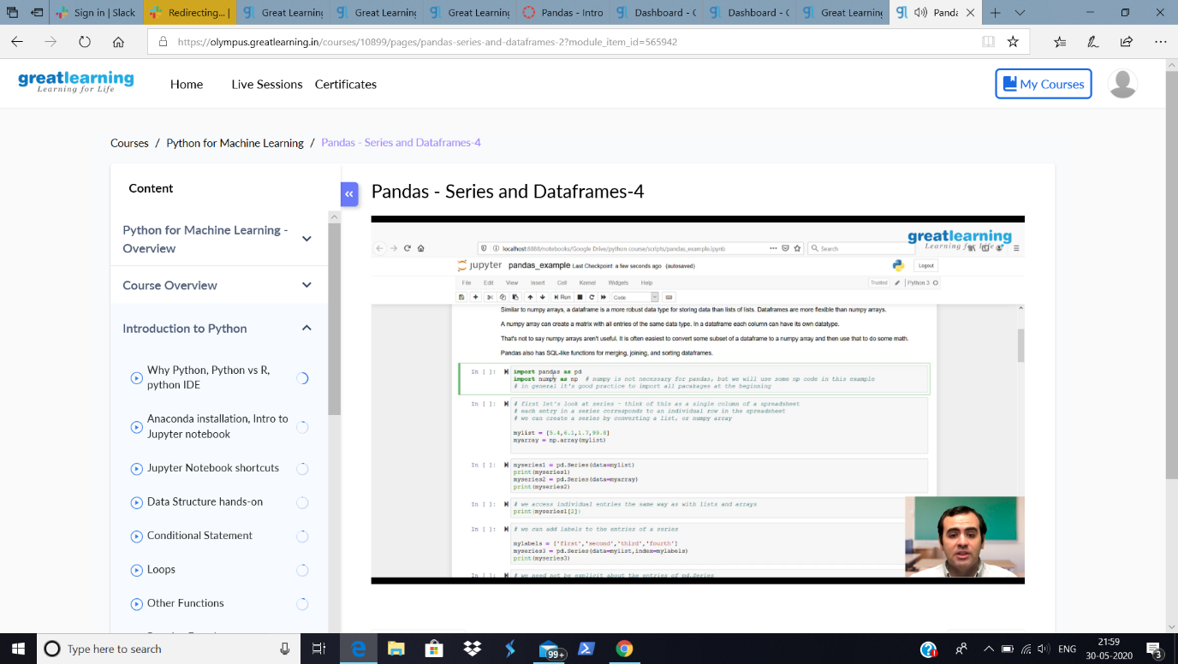

Today I have learnt about pandas- Series and Dataframes.

Coding Challenges Details:

**Problem Statement: Write a C Program to count Uppercase, Lowercase, special character and numeric values for a given String**

**I have written the code and uploaded it in my github.**

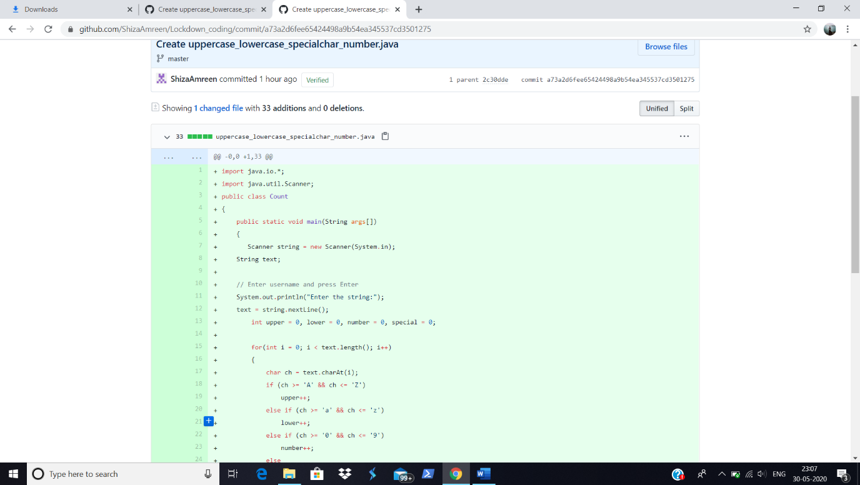

<https://github.com/ShizaAmreen/Lockdown_coding/commit/a73a2d6fee65424498a9b54ea345537cd3501275>